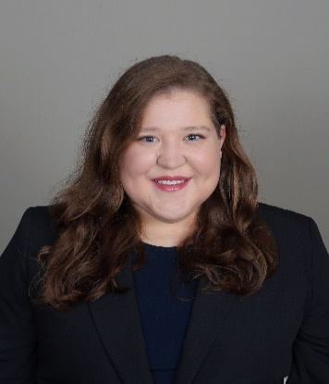
Bianca M. Guzman
Lowe Yeager & Brown PLLC
Attorney
bg@lyb.law

Miss Guzman is licensed in Tennessee, Eastern District of Tennessee, and Florida. She is a proud graduate of the University of Tennessee College of Law, having graduated with High Honors. She enjoys reading, painting, and softball/baseball.

Current  Practice | Lowe Yeager & Brown PLLC  June 2024 – Present  Civil litigation practice including construction matters, wrongful termination, civil rights, legal malpractice, and personal injury.  Representative matters include:  - Representation of parties involving claims of unlicensed contracting, Tennessee Consumer Protection Act, and fraud.  - Representation of complainants in whistleblower protection actions.  - Representation of plaintiffs in personal injury actions.  - Representation of clients in insurance and medical coverage disputes.  - Representation of defendants in legal malpractice claims
Clinics, Internships, and Externships | University of Tennessee, Office of the General Counsel  Summer 2022, May 2023 – May 2024  Drafted legislation on behalf of University of Tennessee campus police; advised departments on University policies, risks, and liabilities; drafted memoranda on federal regulations; and drafted litigation documents.  University of Tennessee Law Clinic – Domestic Violence and Transactions  January 2023 – May 2023, January 2024 – May 2024  Represented Petitioners in seeking Orders of Protection in Knox County 4th Circuit Court; represented non-profit and for-profit corporations by filing articles, drafting bylaws, drafting contracts, and advising clients on various corporate structures and limitations.  United States Attorneys Office, Knoxville, TN – Prosecutorial Externship  August 2023 – November 2023  Drafted a response brief to a motion to suppress; observed trials and hearings; investigated case facts; completed legal research and writing assignments.
Professional Experiences | Program Coordinator for Knoxville Community Law Office, Education Law Program; Special Education teacher; Local Resource Assistant, Nixon Peabody
Education | University of Tennessee College of Law, J.D. 2024 | Simmons College, M.S. Education, 2018 | University of Nevada, Reno, B.S. Neuroscience, 2015

